Hamilton Tours
Example 1
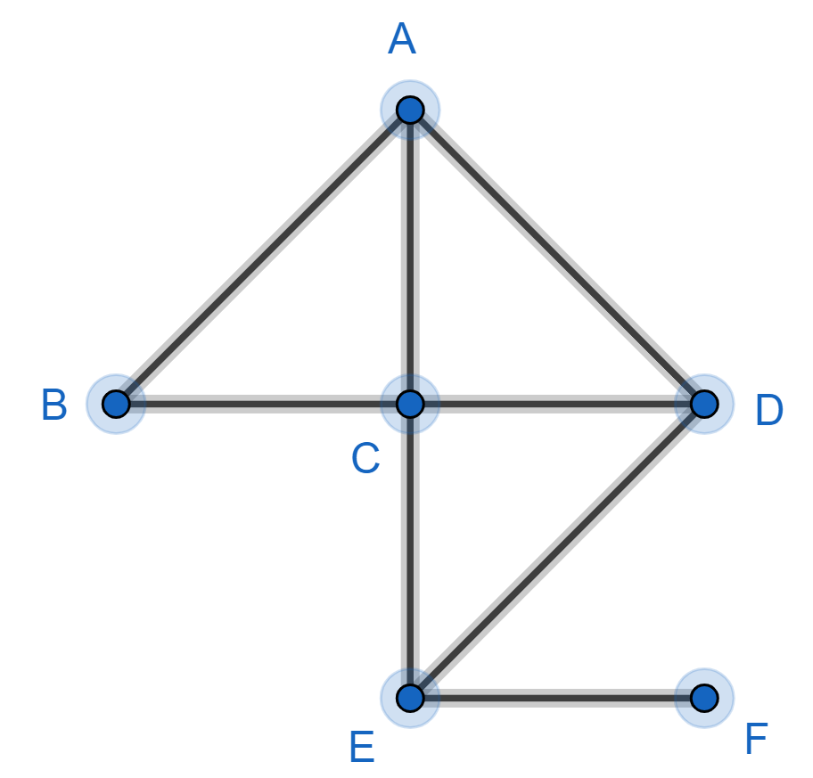

If you walk along the edges of this graph and visit the vertices in the order BADCEF then you have completed a Hamilton tour because you have visited every vertex once (and only once).
This is an open Hamilton tour because the end vertex (F) is not the same as the start vertex (B).

Unlike Euler tours, there are no simple rules to decide if Hamilton tours exists.
Sometimes you can find a Hamilton tour by trial and error. Sometimes you can prove a Hamilton tour does not exist. Sometimes you just don’t know.

Example 2
Look at the graph below where each vertex is marked with a cross or a dot:
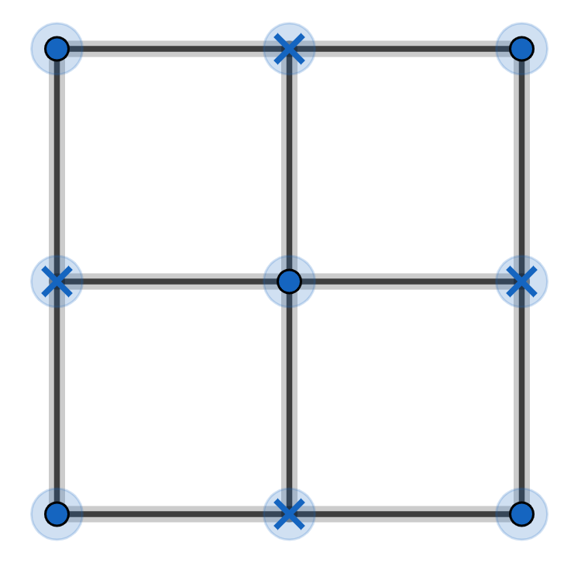

I can find an open Hamilton tour by trial and error. Can you?
I can prove a closed Hamilton tour does not exist:
any Hamilton tour must visit a dot vertex then a cross vertex then a dot vertex then ...
so a closed Hamilton tour must have the same number of dot and cross vertices
but there are 5 dot vertices and 4 cross vertices

Travelling Salesman Problem
Example 2
Here are the distances between five airports A, B, C, D, E:

 | A | B | C | D | E
A | - | 75 | 132 | 125 | 73
B | 75 | - | 65 | 96 | 109
C | 132 | 65 | - | 72 | 137
D | 125 | 96 | 72 | - | 91
E | 73 | 109 | 137 | 91 | -

There are direct flights between all these airports.
Think of the flights as edges and the airports as vertices and we have a graph. (not drawn to scale)

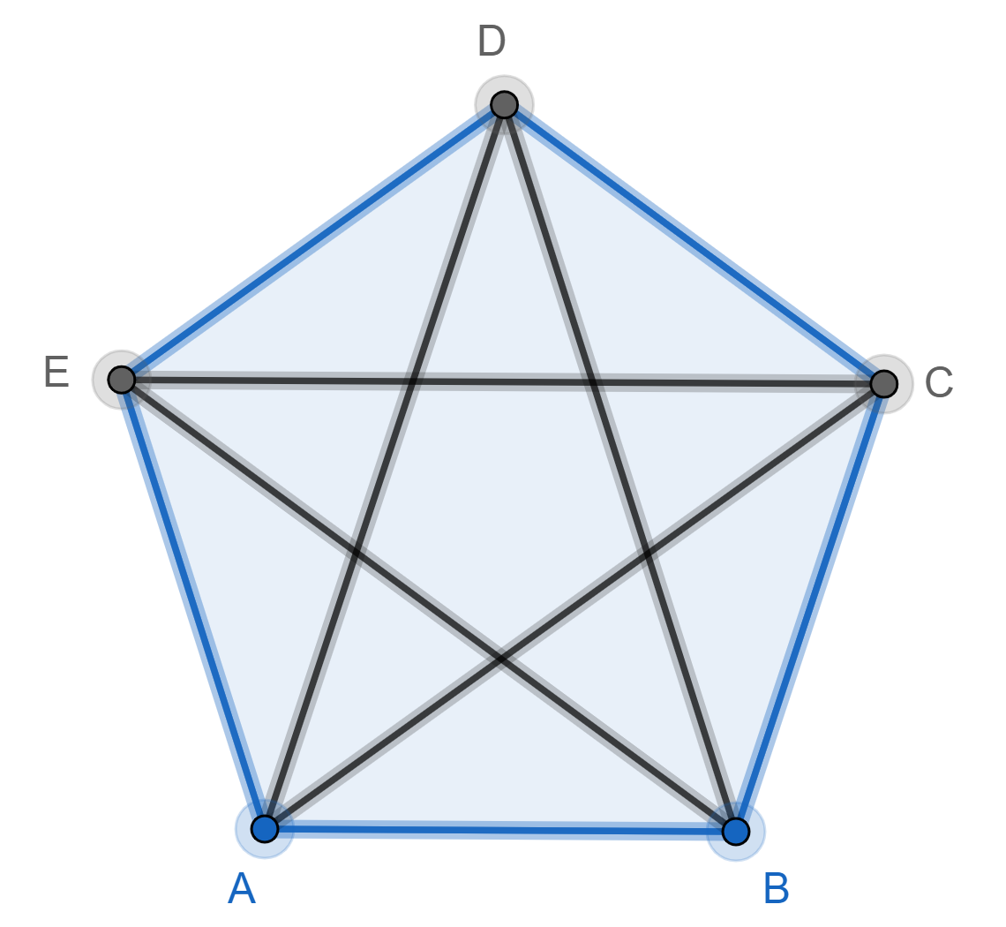

The salesman starts at A, visits every airport once (and only once) and then returns to A. The problem is to find the shortest route. The salesman is looking for the shortest closed Hamilton tour.

The salesman could try the nearest neighbour algorithm:
start at A then fly to the nearest airport not already visited then fly to the nearest airport not already visited then … then return to A
This gives the route: AEDCBA which has length 376

Unfortunately, this algorithm does not always find the shortest route.
So why don’t I give you the algorithm that does always find the shortest route? Because no-one has found such an algorithm!

EXERCISE
1) Does this graph have a Hamilton tour?

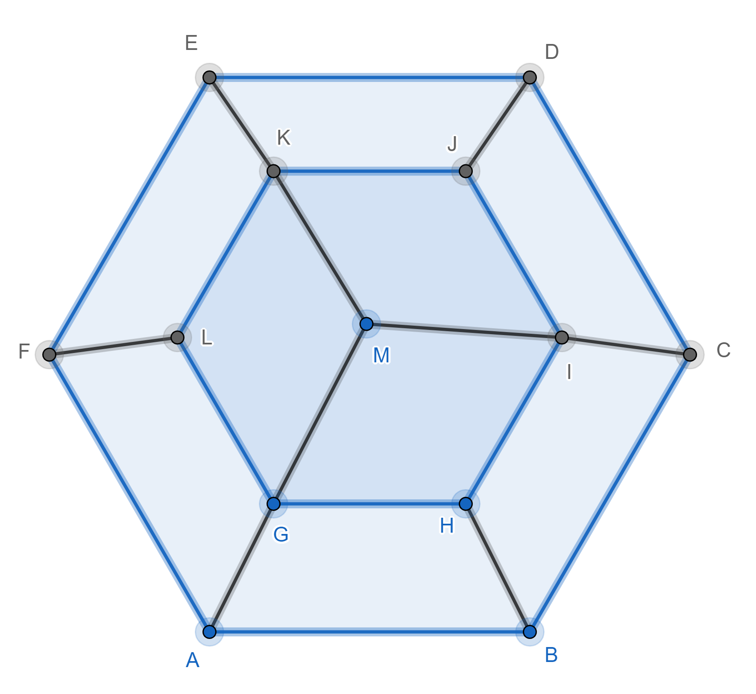

2) There are 4 flowers (A, B, C, D) in a field. A bee starts on flower A, visits each of the other flowers once (and only once) to collect pollen and returns to flower A. Use the nearest neighbour algorithm to find a route.
Here are the distances between the flowers:

 | A | B | C | D
A | - | 85 | 105 | 92
B | 85 | - | 73 | 115
C | 105 | 73 | - | 65
D | 92 | 115 | 65 | -

SOLUTIONS
1) Here is an open tour: ABCDEFLGHIJKM. I found it by trial and error.
We can prove there is no closed tour
Colour vertices A, C, E, L, H, J, M green. Colour vertices B, D, F, G, I, K pink.
Any tour must alternate green, pink, green, pink, ...
A closed tour must have the same number of green and pink vertices but there are 7 green vertices and 6 pink vertices.
2) ABCDA

